**Project Design Phase**

**Technology Stack (Architecture & Stack)**

|  |  |
| --- | --- |
| TEAM ID | PNT2022TMID13519 |
| PROJECT NAME | Real-Time River Water Quality Monitoring and  Controlling System |
| MARKS | 4 Marks |

**TECHNICAL ARCHITECTURE**

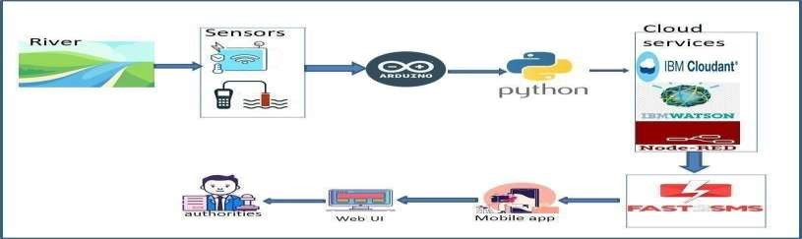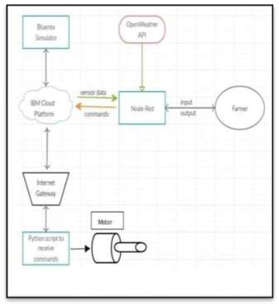

**Table-1 : Components & Technologies:**

|  |  |  |  |
| --- | --- | --- | --- |
| S.No | Component | Description | Technology |
| 1. | User Interface | How user interacts with application | HTML, CSS, Node-Red ,Cloud,etc |
| 2. | Application Logic-1 | Logic for a process in the application | JAVA/PYTHON |
| 3. | Application Logic-2 | Logic for a process in the application | IBM WATSON STT services |
| 4. | Application Logic-3 | Logic for a process in the application | BM WATSON Assistant |
| 5. | Database | Data Type, Configurations etc | MySQL,PostgresSQL |
| 6. | Cloud  Database | Database Service on Cloud | IBM DB2,IBM Cloudant etc |
| 7. | File Storage | File storage requirements | IBM Block Storage or Other Storage Service or Local Filesystem |
| 8. | External API-1 | Purpose of External API used in the application | IBM Weather API, etc |
| 9. | External API-2 | Purpose of External API used in the application | Aadhar API, etc |
| 10. | Machine  Learning  Model | Purpose of External API used in the application | Object Recognition Model, etc.. |
| 11. | Infrastructure  (Server / Cloud) | Application Deployment on Local  System / Cloud  Local Server Configuration:  Cloud Server Configuration : | Local, Cloud Foundry, Kubernetes, etc. |

**Table-2: Application Characteristics:**

|  |  |  |  |
| --- | --- | --- | --- |
| S.No | Characteristics | Description | Technology |
|  | Open-Source Frameworks | List the open-source frameworks used | Technology of  Opensource framework |
| 2. | Security Implementations | List all the security / access controls implemented, use of firewalls etc | e.g. SHA-256,  Encryptions, IAM  Controls, OWASP etc. |
| 3. | Scalable Architecture | Justify the scalability of architecture (3 – tier, Microservices) | Technology used |
| 4. | Availability | Justify the availability of application | Technology used |
| 5. | Performance | Design consideration for the performance of the application | Technology used |